Chapter 1

Multiple Choice (14) WARNING: CORRECT ANSWERS ARE IN THE SAME POSITION AND TAGGED WITH **. YOU SHOULD RANDOMIZE THE LOCATION OF THE CORRECT ANSWERS IN YOUR EXAM.
- Which one of the following is not a high-level language?
  - assembly language **
  - Java
  - Visual Basic
  - Python
- A sequence of instructions is called a(n) _______________ .
  - program **
  - high-level language
  - interpreter
  - flowchart
- A _______________ is any person who runs a program.
  - user **
  - programmer
  - coder
  - computer
- Computer programs are referred to as _______________ .
  - software **
  - hardware
  - flowcharts
  - high-level languages
- The mechanical and electrical devices of a computer are referred to as _______________.
  - hardware **
  - software
  - peripherals
  - programs
- Writing Python statements is called _______________.
  - coding **
  - compiling
  - interpreting
  - processing
- An error is a program is called a(n) _______________.
  - bug **
  - moth
  - incomplete input
  - cycle
- Which programming tool is used to show how the different parts of a program relate to each other?
  - hierarchy chart **
  - flowchart
  - pseudocode
  - algorithm
- Which programming tool graphically depicts the logical steps to carry out a task and show how the steps relate to each other?
  - flowchart **
  - hierarchy chart
  - algorithm
  - pseudocode
- Which programming tool uses English-like phrases with some Python terms to outline the task?
  - pseudocode **
  - algorithm
  - hierarchy chart
  - flowchart
- Hierarchy charts are also called
  - structure charts
  - top-down charts
  - Visual Table of Contents charts
  - all of the above **
- In a flowchart, the representation of instructions that require a “yes” or “no” answer is called a(n) _______________.
  - decision structure **
  - sequence structure
  - binary structure
  - answer structure
- Using different inputs and outputs on a flowchart to test an algorithm is called _______________.
  - desk checking **
  - interpreting
  - flow charting
  - debugging
- Instructions in a Python program are called _______________.
  - source code **
  - editor code
  - debugging code
  - files

True/False (10)
- The word disk is often used to refer to any storage device.
Answer: true
- In the program development cycle, the first step in writing instructions to carry out a task is to determine how to process the input to obtain the desired output.
Answer: false
- Pseudocode is typically more compact than a flowchart.
Answer: true
- In a hierarchy chart, details on how modules work should be included.
Answer: false
- The main benefit of hierarchy charts is in the initial planning phase of a program.
Answer: true
- Flowcharts are time-consuming to write and difficult to update.
Answer: true
- Python requires all programs be saved as a file on a storage device before they can be executed.
Answer: true
- Indentation is not semantically meaningful in Python.
Answer: false
- Python is considered a block-structured language.
Answer: true
- Planning a solution to a problem is called coding.
Answer: false

Short Answer (9)
- Most programs do three general things. List them.
Answer: Take in data, manipulate data, and produce desired results. This is also called input, processing and output.
- Someone preparing for a marathon trains by running laps on a track which is ¼ mile per lap. The runner would like to know their average time in minutes per mile. List the inputs, processing steps and output for a computer program to accomplish this.
Answer: The input is the number of laps and the total time run in minutes. The processing is dividing the laps by 4 to give the miles run, then dividing the time in minutes by the miles. The output is the minutes per mile calculated.
- Fill in the steps of the problem solving process.
Answer:
Input
Processing
Output
- List the 5 steps in the software development life cycle in order.
Answer:
1) analyze
2) design
3) code
4) test and correct
5) complete the documentation
- You are given the following pseudocode to determine if a number is even or odd. Create a hierarchy chart for this program.
get number
If the number is divisible by 2 without a remainder
display the number is even
else
display the number is odd
Answer:
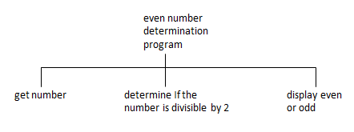
- You are given the following pseudocode to determine if a number is even or odd. Create a flowchart for this program.
get number
If the number is divisible by 2 without a remainder
display the number is even
else
display the number is odd
Answer:
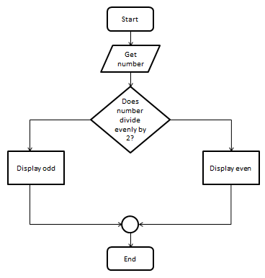

- Given the following flowchart for a program that determines if a number is even or odd, write the pseudocode.
Answer:
get number
If the number is divisible by 2 without a remainder
display the number is even
else
display the number is odd

- Write a line of Python code that displays the sum of 468 + 751.
Answer: print (468 + 751)

- Write a line of Python code that displays the words “How are you?” to the screen.
Answer: print (“How are you?”)

