1. What does the discipline of ecology study?
 | a. | relationships between organisms and their environment
 | b. | how endangered plants are cultivated
 | c. | how animals behave and breed
 | d. | the mechanisms of global climate change

ANSWER: | a

2. What is environmentalism?
 | a. | It is the science of studying the structure and function of nature.
 | b. | It refers specifically to radical acts performed to focus attention on the environment.
 | c. | It is a social movement dedicated to protecting the Earth’s life support systems.
 | d. | It is the sum total of everything that has been written about outdoor science.

ANSWER: | c

3. Which of the following is NOT considered part of natural capital?
 | a. | soil
 | b. | sunlight
 | c. | water
 | d. | air

ANSWER: | b

4. Which is the best description of how an environmentally sustainable society manages its resources?
 | a. | it satisfies the needs of its people by harvesting without depleting Earth’s capital
 | b. | it focuses on all levels of society having sustainable incomes
 | c. | it satisfies all society’s needs by not harvesting any new materials
 | d. | it focuses on today’s society’s needs and the needs of endangered species

ANSWER: | a

5. Which of the following is NOT an example of exponential growth?
 | a. | the king who promised to double the number of grains of wheat he put on each successive square of a checkerboard
 | b. | human population growth
 | c. | a stock portfolio that increases at 15% one year, then 275% the next, then 42% the next
 | d. | money in a savings account

ANSWER: | c

6. What is the best description of the growth rate of most of the environmental problems we face?
 | a. | the problems are increasing exponentially
 | b. | the problems are increasing linearly
 | c. | the problems are decreasing linearly
 | d. | the problems are decreasing exponentially

ANSWER: | a

7. What is the pace of exponential growth?
 | a. | it starts rapidly and remains rapid
 | b. | it starts out slowly then becomes very rapid
 | c. | it starts out slowly and remains slow
 | d. | it remains constant

ANSWER: | b

8. The world’s population of approximately 7.2 billion people is growing at about 1.2% a year. Considering how many people are being added to the world each day, how long would it take to populate a city the size of Vancouver (604,000 people)?
 | a. | 3 days
 | b. | 1 week
 | c. | 1 month
 | d. | 6 weeks

ANSWER: | a

9. Which statement characterizes economic development?
 | a. | it is an increase in the capacity of a country to provide people with goods and services
 | b. | it is encouraged by increased consumption per capita
 | c. | it is encouraged by population growth
 | d. | it is the improvement of living standards by economic growth

ANSWER: | d

10. Which term defines the market value of goods and services produced in a country for use within a year (expressed in dollars)?
 | a. | gross domestic product
 | b. | gross national product
 | c. | per capita GNP
 | d. | per capita GDP

ANSWER: | a

11. Which statement characterizes developing countries?
 | a. | they include the United States, Canada, Japan, and the former Soviet Union
 | b. | they have high average GNPs per person
 | c. | they make up about one-tenth of the world’s population
 | d. | they use about 12% of the world’s resources

ANSWER: | d

12. Which statement characterizes developed countries?
 | a. | they make up 17% of the world’s population
 | b. | they are primarily in Africa, Asia, and Latin America
 | c. | they have low to moderate GNPs per person
 | d. | they experience annual population growth of about 16%

ANSWER: | a

13. On what does the United Nations base their classification of the world’s countries as “developed” or “developing”?
 | a. | their degree of political stability and their social equality
 | b. | their degree of industrialization and their per capita GDP
 | c. | their degree of environmental sustainability and their social equality
 | d. | their ecological footprint alone

ANSWER: | b

14. What percentage of the world’s human population lives in developed countries?
 | a. | 57%
 | b. | 37%
 | c. | 17%
 | d. | 7%

ANSWER: | c

15. What is globalization?
 | a. | a new term for mass immigration into a country
 | b. | a satellite-based communications system
 | c. | worldwide integration of social, economic, and environmental change
 | d. | the ability of all of society to travel worldwide

ANSWER: | c

16. How can sustainable development be distinguished from economic development in terms of its emphasis?
 | a. | intergenerational equity
 | b. | setting limits on human population growth
 | c. | meeting the needs of people
 | d. | use of economic systems and the earth’s resources

ANSWER: | a

17. What best describes renewable resources?
 | a. | they can be replenished fairly rapidly on a human time scale through natural processes
 | b. | they are things like winds, tides, and flowing water
 | c. | they are renewed continuously on a human time scale
 | d. | they are things that are continually available like direct solar energy

ANSWER: | a

18. What is a common-property resource?
 | a. | an environmentally depleted resource not available for users
 | b. | a resource owned by a group of private owners that is available for all owners
 | c. | a resource that has a number of different uses and is available for all owners
 | d. | no individuals own the resource, and it is available for all users

ANSWER: | d

19. Which resource is a non-metallic mineral resource?
 | a. | water
 | b. | soil
 | c. | oil
 | d. | sand

ANSWER: | d

20. Which resource is NOT renewable?
 | a. | trees in a forest
 | b. | oil
 | c. | fertile soil
 | d. | groundwater

ANSWER: | b

21. Which type of resource is identified by the use of a natural resource based on sustainable yield?
 | a. | perpetual resources
 | b. | non-renewable resources
 | c. | amenity resources
 | d. | renewable resources

ANSWER: | d

22. What best describes the concept of environmental degradation?
 | a. | letting agricultural runoff cause oxygen depletion and fish kills downstream
 | b. | using oil to make gasoline
 | c. | using solar power at a rapid rate
 | d. | cutting trees for wood products

ANSWER: | a

23. Which statement best illustrates the tragedy of the commons?
 | a. | Irrigated cropland can be ruined by salinization.
 | b. | Some levels of pollution are life threatening.
 | c. | Some activities harm the environment, but others do not.
 | d. | A factory pollutes a river as much as the law allows.

ANSWER: | d

24. Which statement about ecological footprint, on a per capita basis (global hectares per person), is accurate?
 | a. | it is 6.8 in Canada, equal to the that of the United States
 | b. | it is 3.4 in Canada significantly lower than the United States
 | c. | it is the highest in the United States at 3.8
 | d. | it is the highest in India at 7.2

ANSWER: | a

25. Which situation is an example of new efforts to prevent the tragedy of the commons?
 | a. | converting land from private to more public ownership
 | b. | using common-property resources at or above their sustainable yields
 | c. | moving from a taxpayer-pay approach to a user-pay approach
 | d. | moving from a user-pay approach to a taxpayer-pay approach

ANSWER: | c

26. Which statement characterizes renewable resources?
 | a. | renewable resources includes fertile soil and clean water
 | b. | renewable resources are the only resources that are alive
 | c. | renewable resources are also called perpetual resources
 | d. | renewable resources include natural gas and forests

ANSWER: | a

27. What can theoretically happen to all non-renewable resources?
 | a. | they can be converted to non-metallic minerals
 | b. | they can be converted to renewable resources
 | c. | they can be exhausted or depleted
 | d. | they can be naturally replaced in a relatively short time

ANSWER: | c

28. What can we do when a resource is economically depleted?
 | a. | find new reserves of the resource
 | b. | develop substitutes for that resource
 | c. | increase the price of the resource
 | d. | use a common-property approach

ANSWER: | b

29. Which of the following is NOT a point source of pollution?
 | a. | pesticides sprayed into the air
 | b. | an automobile tailpipe
 | c. | a factory smokestack
 | d. | a drainpipe from a power plant

ANSWER: | a

30. Which of the following is NOT a nonpoint source of pollution?
 | a. | pesticides dispersed by airplane and wind onto a crop
 | b. | runoff from a stockyard
 | c. | a smokestack from a power plant
 | d. | fertilizer runoff from lawns

ANSWER: | c

31. You generally buy and eat microwave dinners. After dinner, cardboard tops and plastic trays remain. What is the least effective way to deal with this type of solid-waste problem?
 | a. | prepare large quantities of food and divide it into your own reusable microwave containers
 | b. | donate the plastic containers to the local nursery schools to use with preschoolers
 | c. | collect the components and incinerate them so they don’t take up landfill space
 | d. | recycle the components

ANSWER: | c

32. What is NOT important in determining the damage produced by a pollutant?
 | a. | persistence
 | b. | origin
 | c. | concentration
 | d. | chemical nature

ANSWER: | b

33. Why are pollution cleanup efforts ineffective?
 | a. | they often transfer pollutants from one part of the environment to another
 | b. | we lack technology to clean up most pollution
 | c. | too much effort and funding is focused on pollution prevention
 | d. | because efforts are only effective with nonpoint sources, not point sources

ANSWER: | a

34. What is the root cause of environmental problems?
 | a. | climate change
 | b. | water pollution
 | c. | rapid population growth
 | d. | food supply problems

ANSWER: | c

35. What is NOT one of the big five major causes of environmental problems?
 | a. | ecological ignorance
 | b. | the climate in which people live
 | c. | poverty
 | d. | population

ANSWER: | b

36. What is NOT one of the four major preventable health problems that many of the world’s desperately poor children die prematurely from?
 | a. | AIDS
 | b. | malnutrition
 | c. | infectious conditions like diarrhea
 | d. | respiratory disease from the indoor burning of wood and coal

ANSWER: | a

37. What is the primary reason poor people often have more children?
 | a. | they have many children for economic security
 | b. | they have many children for social status
 | c. | they have many children because they do not believe in birth control
 | d. | they have many children because they cannot afford birth control

ANSWER: | a

38. Which evidence is likely to form the basis of an economist’s opinion?
 | a. | The human population is growing exponentially.
 | b. | Consensus science suggests that potential global climate change, deforestation, and species loss should be taken as serious problems.
 | c. | The rate of crop yield increases is declining.
 | d. | People are our most important resource.

ANSWER: | d

39. Which evidence is likely to form the basis of an environmentalist’s opinion?
 | a. | Food is more abundant and cheaper than at any other time in human history.
 | b. | Total forest area of the temperate zone region’s industrialized countries increased during the 1980s.
 | c. | Consensus science suggests that potential global climate change, deforestation, and species loss should be taken as serious problems.
 | d. | The rate of human population growth is declining.

ANSWER: | c

40. Which statement is representative of an environmental wisdom worldview?
 | a. | More money should be directed to research on controlling the environment.
 | b. | Continuous rapid economic growth will improve environmental conditions.
 | c. | Human beings are the most important life forms on Earth.
 | d. | Energy and materials efficiency must continually be improved.

ANSWER: | d

41. An environmentally sustainable society must be based on policies that provide for economic growth and development.
 | a. | True
 | b. | False

ANSWER: | False

42. Developed countries have a significant negative effect on the environment because of high levels of consumption per person and high technological impact per unit of consumption.
 | a. | True
 | b. | False

ANSWER: | True

43. The “tragedy of the commons” refers to a lack of agricultural sustenance available for the common (poor) people in a country.
 | a. | True
 | b. | False

ANSWER: | False

44. Affluenza increases man’s ecological footprint and compromises environmental quality for people all over the world.
 | a. | True
 | b. | False

ANSWER: | True

45. Decreasing population growth in developed countries will decrease resource consumption.
 | a. | True
 | b. | False

ANSWER: | False

46. The per capita ecological footprint is the availability of productive land and usable water to support the population with no consideration for environmental impact.
 | a. | True
 | b. | False

ANSWER: | True

47. As in a human body, the Earth’s capacity to repair itself is critical to its survival.
 | a. | True
 | b. | False

ANSWER: | True

48. When a country’s GDP decreases, the per capita GDP must also decrease.
 | a. | True
 | b. | False

ANSWER: | False

49. An environmentally sustainable society will require most affluent consumers in developed countries to rethink and reduce their consumption of commercial products.
 | a. | True
 | b. | False

ANSWER: | True

50. Natural capital degradation is a by-product of economic development.
 | a. | True
 | b. | False

ANSWER: | True

51. Poverty, pollution, water shortages, and degradation of biodiversity are the major causes of most current environmental problems.
 | a. | True
 | b. | False

ANSWER: | False

52. Most pollution from human activities is concentrated near urban and industrial areas, although this pollution can also be spread over vast distances by wind and flowing water.
 | a. | True
 | b. | False

ANSWER: | True

53. When a non-renewable resource is completely exhausted, it is referred to as economically depleted.
 | a. | True
 | b. | False

ANSWER: | False

54. Pollution cleanup is considered a short-term solution if population and consumption levels grow without corresponding improvement in pollution control technology.
 | a. | True
 | b. | False

ANSWER: | True

55. Rapid population growth and poverty are reflective of developing countries and have little impact on pollution.
 | a. | True
 | b. | False

ANSWER: | False

56. It is better to rely on pollution prevention rather than on pollution cleanup because the former choice generally protects the environment more effectively and generally costs less in the long run than pollution cleanup.
 | a. | True
 | b. | False

ANSWER: | True

57. Developing countries have an increase in premature deaths primarily because of malnutrition.
 | a. | True
 | b. | False

ANSWER: | False

58. Overall, the air quality is poorer and drinking water more polluted today than in the 1970s.
 | a. | True
 | b. | False

ANSWER: | False

59. A resource such as solar energy that is renewed continuously is a called a(n) ____________________ resource.
ANSWER: | perpetual

60. ___________________ ____________________ economic development promotes beneficial and benign economic activities while discouraging environmentally harmful economic activities.
ANSWER: | Environmentally sustainable

61. _____________ _________________ is a possible solution to the problem of people exploiting a free-access resource but may not be practical for global common resources.
ANSWER: | Private ownership

62. Non-renewable resources include _______________ resources such as oil and natural gas that cannot be recycled.
ANSWER: | energy

63. ____________________ growth increases at a constant rate per unit time and may appear to start slowly, but it soon grows to enormous numbers as additional growth continues to be added to the earlier growth.
ANSWER: | exponential

64. A chemical dumpsite would be an example of a ____________ _____________ pollutant.
ANSWER: | point source

65. Population (P) × Consumption per person (affluence, A) × _____________________________________________ = Environmental impact of population (I).
ANSWER: | Technological impact per unit of consumption (T)

66. Societies consisting of populations with exponential growth may exceed the area’s _________________ __________________ and thus be unsustainable.
ANSWER: | carrying capacity

67. If you have more than five credit cards and shop when you are depressed, you may have ____________________.
ANSWER: | affluenza

68. Fish, freshwater, wild animals, and fertile soil are examples of _______________ ____________________.
ANSWER: | renewable resources

69. A social movement dedicated to protecting the earth’s life support system for all living things is called _________________________.
ANSWER: | environmentalism

70. Canada and Spain almost went to war over ____________________.
ANSWER: | fish

71. Food, water, shelter, and manufactured goods are____________________ used to meet human needs and wants.
ANSWER: | resources

72. The consequence of volcanic eruptions and burning coal is ____________________.
ANSWER: | pollution

73. The old drink bottles that were collected, washed, and refilled are an example of ____________________.
ANSWER: | reuse

74. Installing runoff curtains in a construction site is an example of ____________ __________________.
ANSWER: | pollution prevention

75. Developing countries have a(n) _________ ___________ which proposes a threat to their ability to become environmentally sustainable.
ANSWER: | low GDP

76. Leaving drink cans and plastic materials at a campsite is an example of ____________________.
ANSWER: | pollution

77. _______________-__________________ resources are not owned by a single person or organization but are degraded by many people.
ANSWER: | Common-property  Free-access

Figure 1-3

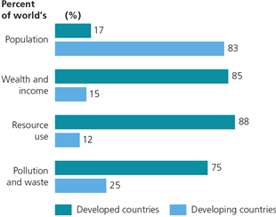

78. Based on this graph, what is significant about the world’s percentage of resource use in developed countries?
ANSWER: | Developed countries’ populations use about 88% of the world’s resources.

79. Based on the above graph, how might the disproportionate use of resources by developed countries be reduced?
ANSWER: | — less dependence on fossil fuel  — change from a “throw-away” philosophy  — decrease waste of resources, etc.  ​

Figure 1-7

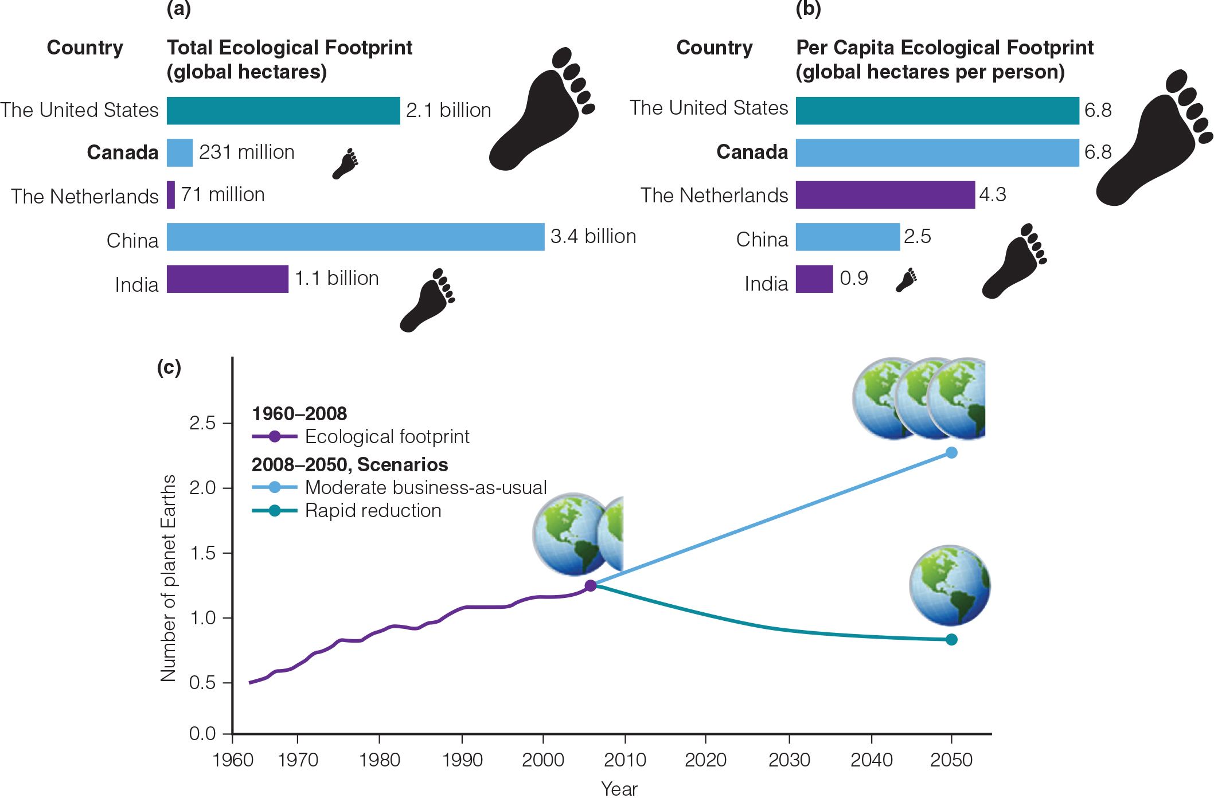

80. What is the percent difference between humanity’s ecological footprint and Earth’s ecological capacity?
ANSWER: | 50% as of 2008, and the percentage is growing

81. What will happen if humanity’s ecological footprint continues to be greater than Earth’s ecological capacity?
ANSWER: | ​— Humans will destroy their environment.  — More and more animal and plant species will be lost.  — Poverty and disease will increase, etc.

82. How does Canada’s ecological footprint compare to that of the Netherlands?
ANSWER: | Canada’s ecological footprint is over three times as high.

83. What does the difference in ecological footprint between India and the Netherlands mean?
ANSWER: | India’s overall effect on the environment is more severe than that of the Netherlands.

Figure 1-10

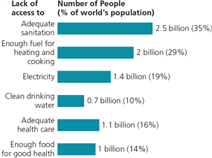
​

84. What is the percentage of the world’s population that does not have adequate sanitation?
ANSWER: | 35

85. Considering that access to clean drinking water and adequate sanitation are required for health, what percentage of the problems illustrated in Figure 1-10 represent direct health-related problems?
ANSWER: | (2.5 + 0.7 + 1.1 + 1.0) / 8.7 = 61%

