1. What is the ground state electron configuration of carbon?

- 1s²2s²2p_{x}1

- 1s²2s²2p_{x}2
- 1s²2s²2p_{x}1_{2py1}

- 1s²2s²2p_{x}2_{2py1}

Accessibility: Keyboard Navigation

Bloom's Level: 3. Apply

Chapter: 01

Difficulty: Medium

Gradable: automatic

Section: 01.01

Subtopic: Periodic table trends

Topic: Structure and Bonding

2. Which of the following has (have) the same electron configuration as Ne?

Na⁻ Mg²⁺ O²⁻ Mg⁺

- Na⁻ and O²⁻
- Mg²⁺ and O²⁻
- Mg⁺ and O²⁻
- only Mg²⁺

Accessibility: Keyboard Navigation

Bloom's Level: 4. Analyze

Chapter: 01

Difficulty: Medium

Gradable: automatic

Section: 01.02

Subtopic: Periodic table trends

Topic: Structure and Bonding

3. What is the letter designation given to dumbbell shaped orbitals like the one depicted below?
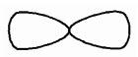

- s

- p

- d

- f

Bloom's Level: 1. Remember

Chapter: 01

Difficulty: Easy

Gradable: automatic

Section: 01.01

Subtopic: Atomic orbitals

Topic: Molecular Shape

- Which of the following atoms has vacant d orbitals that permit it to accommodate more than eight electrons in its valence shell?

- N

- C

- Ne

- S

Accessibility: Keyboard Navigation

Bloom's Level: 2. Understand

Chapter: 01

Difficulty: Easy

Gradable: automatic

Section: 01.08

Subtopic: Octet rule exceptions

Topic: Structure and Bonding

5. Predict which bond is the most polar in ethanol, CH₃CH₂OH?

- C-C

- C-H

- C-O

- O-H

Accessibility: Keyboard Navigation

Bloom's Level: 4. Analyze

Chapter: 01

Difficulty: Medium

Gradable: automatic

Section: 01.04

Subtopic: Bond properties

Subtopic: Types of bonds

Topic: Structure and Bonding

6. Which one of the following is the conjugate base of NH₃?

- NH₄+

- H⁺
C. _{N}3-
D. NH₂⁻

Accessibility: Keyboard Navigation

Bloom's Level: 3. Apply

Chapter: 01

Difficulty: Medium

Gradable: automatic

Section: 01.12

Subtopic: Acid/Base definitions

Topic: Acids and Bases

7. What can be said about the polarity of the C=O bond?

- C and O have the same electronegativity; the bond is nonpolar

- the C=O bond is polar; the O atom bears a partial negative charge

- the C=O bond is nonpolar; the C atom bears a partial positive charge

- the C=O bond is polar; the C atom bears a partial negative charge

Accessibility: Keyboard Navigation

Bloom's Level: 2. Understand

Chapter: 01

Difficulty: Medium

Gradable: automatic

Section: 01.04

Subtopic: Bond properties

Subtopic: Types of bonds

Topic: Structure and Bonding

8. Identify the condensed formula of the following structure:
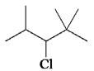

A. (CH₃)₂CHCHClCH(CH₃)₂

B. CH₃CH(CH₃)CHClCH(CH₃)₂
C. (CH₃)₂CHCHClC(CH₃)₃
D. (CH₃)₃CCHClCH(CH₃)₃

Bloom's Level: 3. Apply

Chapter: 01

Difficulty: Medium

Gradable: automatic

Section: 01.06

Subtopic: Condensed formula

Subtopic: Skeletal/bond-line structures

Topic: Drawing Organic Molecules

9. What is the chemical formula of the following carbon skeleton diagram?
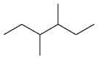

- C₈H₁₄

- C₈H₁₆
- C₈H₁₈
- C₈H₂₀

Bloom's Level: 2. Understand

Chapter: 01

Difficulty: Easy

Gradable: automatic

Section: 01.06

Subtopic: Skeletal/bond-line structures

Topic: Drawing Organic Molecules

10. How many hydrogen atoms are there on carbon atoms 1 and 2, respectively, in the structure below?
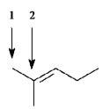

- 4, 1

- 4, 0

- 3, 1

- 3, 0

Bloom's Level: 2. Understand

Chapter: 01

Difficulty: Medium

Gradable: automatic

Section: 01.06

Subtopic: Skeletal/bond-line structures

Topic: Drawing Organic Molecules

11. How many C₃H₈O constitutional isomers are possible?

- one

- two

- three

- four

Accessibility: Keyboard Navigation

Bloom's Level: 3. Apply

Chapter: 01

Difficulty: Medium

Gradable: automatic

Section: 01.06

Subtopic: Constitutional isomers

Topic: Drawing Organic Molecules

12. Which of the following best describes the relationship between the two structures?
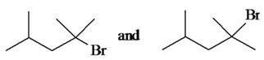

- identical compounds

- resonance structures

- constitutional isomers

- different compounds with different constitutions

Bloom's Level: 2. Understand

Chapter: 01

Difficulty: Medium

Gradable: automatic

Section: 01.06

Subtopic: Skeletal/bond-line structures

Topic: Drawing Organic Molecules

13. How many constitutional isomers of C₄H₉Br are possible?

- one

- two

- three

- four

Accessibility: Keyboard Navigation

Bloom's Level: 3. Apply

Chapter: 01

Difficulty: Medium

Gradable: automatic

Section: 01.06

Subtopic: Constitutional isomers

Topic: Drawing Organic Molecules

14. How many constitutional isomers of C₃H₆Cl₂ are possible?

- three

- four

- five

- six

Accessibility: Keyboard Navigation

Bloom's Level: 3. Apply

Chapter: 01

Difficulty: Medium

Gradable: automatic

Section: 01.06

Subtopic: Constitutional isomers

Topic: Drawing Organic Molecules

15. What is the formal charge on the carbon atom?
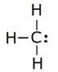

- +1

- 0

- -1

- -2

Bloom's Level: 3. Apply

Chapter: 01

Difficulty: Medium

Gradable: automatic

Section: 01.05

Subtopic: Formal charges

Topic: Structure and Bonding

16. Which of the following describes the relationship between the following two structures?

- identical structures

- resonance forms

- constitutional isomers

- different compounds with different compositions

Bloom's Level: 2. Understand

Chapter: 01

Difficulty: Medium

Gradable: automatic

Section: 01.06

Subtopic: Skeletal/bond-line structures

Topic: Drawing Organic Molecules

17. Which of the following describes the relationship between the following two ions?
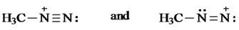

- identical structures

- resonance forms

- constitutional isomers

- different compounds with different compositions

Bloom's Level: 2. Understand

Chapter: 01

Difficulty: Easy

Gradable: automatic

Section: 01.07

Subtopic: Resonance

Topic: Structure and Bonding

18. What is the formal charge on the oxygen atom in the structure below?
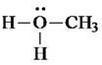

- -1

- 0

- +1

- +2

Bloom's Level: 3. Apply

Chapter: 01

Difficulty: Medium

Gradable: automatic

Section: 01.05

Subtopic: Formal charges

Topic: Structure and Bonding

19. What is the formal charge on the nitrogen atom in the structure below?
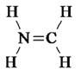

- -1

- 0

- +1

- +2

Bloom's Level: 3. Apply

Chapter: 01

Difficulty: Medium

Gradable: automatic

Section: 01.05

Subtopic: Formal charges

Topic: Structure and Bonding

20. The formal charges on the nitrogen and oxygen in the following structures are, respectively
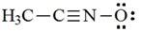

- +1, -1

- 0, -1

- +1, 0

- 0, 0

Bloom's Level: 3. Apply

Chapter: 01

Difficulty: Medium

Gradable: automatic

Section: 01.05

Subtopic: Formal charges

Topic: Structure and Bonding

- In which of the following compounds would you expect Cl to have a partial positive charge?

- HCl

- CCl₄

- NaCl

- HOCl

Accessibility: Keyboard Navigation

Bloom's Level: 2. Understand

Chapter: 01

Difficulty: Medium

Gradable: automatic

Section: 01.04

Subtopic: Bond properties

Subtopic: Types of bonds

Topic: Structure and Bonding

22. Based on the VSEPR model, which of the following species has (have) a trigonal planar geometry?

I. BCl₃ II. NH₃ III. NO₃¯

- only I

- I and II

- I and III

- I, II, and III

Accessibility: Keyboard Navigation

Bloom's Level: 3. Apply

Chapter: 01

Difficulty: Hard

Gradable: automatic

Section: 01.09

Subtopic: VSEPR theory

Topic: Molecular Shape

23. Based on VSEPR theory, which of the following species has (have) a trigonal pyramidal geometry?

I. CO₃2- II. NH₃ III. CH₃+

- only I

- only II

- I and II

- II and III

Accessibility: Keyboard Navigation

Bloom's Level: 3. Apply

Chapter: 01

Difficulty: Hard

Gradable: automatic

Section: 01.09

Subtopic: VSEPR theory

Topic: Molecular Shape

24. Which of the following species has(have) a linear geometry?

I. CO₂ II. NO₂ + III. NO₂¯

- only I

- only II

- I and II

- I, II, and III

Accessibility: Keyboard Navigation

Bloom's Level: 3. Apply

Chapter: 01

Difficulty: Hard

Gradable: automatic

Section: 01.09

Subtopic: VSEPR theory

Topic: Molecular Shape

25. Which of the following molecules would you expect to have a dipole moment?

  - CO₂ II. HCN III. CHCl₃

- II and III

- only II

- only III

- I, II, and III

Accessibility: Keyboard Navigation

Bloom's Level: 4. Analyze

Chapter: 01

Difficulty: Hard

Gradable: automatic

Section: 01.10

Subtopic: Dipole moments

Subtopic: Polarity of molecules

Topic: Molecular Shape

26. Which of the following molecules would you expect to have a dipole moment?

  - CH₂Cl₂ II. CH₃Cl III. CCl₄

- only I

- only II

- I and II

- I, II, and III

Accessibility: Keyboard Navigation

Bloom's Level: 4. Analyze

Chapter: 01

Difficulty: Hard

Gradable: automatic

Section: 01.10

Subtopic: Dipole moments

Subtopic: Polarity of molecules

Topic: Molecular Shape

27. The H-C-H bond angles in ethylene, C₂H₄, are closest to

- 90°.

- 109.5°.

- 120°.

- 180°.

Accessibility: Keyboard Navigation

Bloom's Level: 2. Understand

Chapter: 01

Difficulty: Medium

Gradable: automatic

Section: 01.09

Subtopic: Hybridization

Topic: Molecular Shape

28. The C-C-C bond angle in propane, C₃H₈, is closest to

- 90°.

- 109.5°.

- 120°.

- 180°.

Accessibility: Keyboard Navigation

Bloom's Level: 2. Understand

Chapter: 01

Difficulty: Medium

Gradable: automatic

Section: 01.09

Subtopic: Hybridization

Topic: Molecular Shape

29. What are the formal charges of boron and nitrogen, respectively, in the following structure?
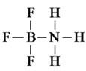

- -1 and +1

- -1 and 0

- 0 and +1

- 0 and 0

Bloom's Level: 3. Apply

Chapter: 01

Difficulty: Medium

Gradable: automatic

Section: 01.05

Subtopic: Formal charges

Topic: Structure and Bonding

30. Which one of the following is isoelectronic with CO₂?

- NO₂¯

- NO₂+
- NO₂
- O₃

Accessibility: Keyboard Navigation

Bloom's Level: 4. Analyze

Chapter: 01

Difficulty: Hard

Gradable: automatic

Section: 01.10

Subtopic: Dipole moments

Subtopic: Polarity of molecules

Subtopic: VSEPR theory

Topic: Molecular Shape

- In which of the following does hydrogen have a partial negative charge based on electronegativity?

- BH₃

- CH₄
- NH₃

- H₂O

Accessibility: Keyboard Navigation

Bloom's Level: 2. Understand

Chapter: 01

Difficulty: Medium

Gradable: automatic

Section: 01.04

Subtopic: Bond properties

Subtopic: Types of bonds

Topic: Structure and Bonding

32. Which of the following species have a zero formal charge on its carbon atom?
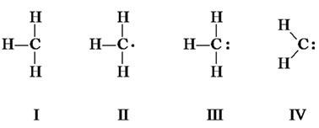

- I and II

- II and IV

- III and IV

- I, II, and III

Bloom's Level: 3. Apply

Chapter: 01

Difficulty: Medium

Gradable: automatic

Section: 01.05

Subtopic: Formal charges

Topic: Structure and Bonding

33. Which one of the following species is formed when diazomethane loses a nitrogen molecule?
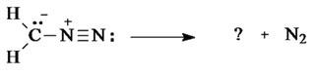

diazomethane
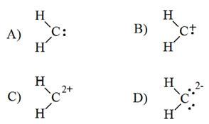

- A

- B

- C

- D

Bloom's Level: 3. Apply

Chapter: 01

Difficulty: Hard

Gradable: automatic

Section: 01.11

Subtopic: Bond formation and bond breaking

Subtopic: Drawing and interpretation

Topic: Curved Arrows

34. Which species is formed when the CH₃N₂⁺ cation loses a nitrogen molecule?
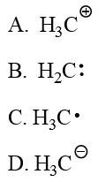

- A

- B

- C

- D

Bloom's Level: 3. Apply

Chapter: 01

Difficulty: Hard

Gradable: automatic

Section: 01.11

Subtopic: Bond formation and bond breaking

Subtopic: Drawing and interpretation

Topic: Curved Arrows

35. Give the molecular formula of the compound shown below:
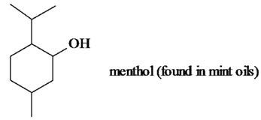

- C₈H₁₆O

- C₉H₁₈O
- C₁₀H₁₈O
- C₁₀H₂₀O

Bloom's Level: 2. Understand

Chapter: 01

Difficulty: Medium

Gradable: automatic

Section: 01.06

Subtopic: Skeletal/bond-line structures

Topic: Drawing Organic Molecules

36. The electron pair movement depicted below produces a second resonance form for the species. What is the formal charge on the nitrogen atom for this second resonance form?
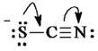

- -2

- -1

- 0

- +1

Bloom's Level: 3. Apply

Chapter: 01

Difficulty: Hard

Gradable: automatic

Section: 01.07

Subtopic: Bond formation and bond breaking

Subtopic: Drawing and interpretation

Subtopic: Formal charges

Subtopic: Resonance

Topic: Curved Arrows

Topic: Structure and Bonding

37. Which statement correctly describes the structures of BH₃ and NH₃?

- Both are trigonal and planar.

- Both are pyramidal.

- BH₃ is trigonal planar and NH₃ is trigonal pyramidal.

- BH₃ is trigonal pyramidal and NH₃ is trigonal planar.

Accessibility: Keyboard Navigation

Bloom's Level: 3. Apply

Chapter: 01

Difficulty: Hard

Gradable: automatic

Section: 01.09

Subtopic: VSEPR theory

Topic: Molecular Shape

38. Which one of the following is the conjugate acid of ethanol?

- CH₃CH₂O⁻

- CH₃CH₂O⁺
- CH₃CH₂OH₂+
- CH₃CH₂OH₃+

Accessibility: Keyboard Navigation

Bloom's Level: 2. Understand

Chapter: 01

Difficulty: Medium

Gradable: automatic

Section: 01.12

Subtopic: Acid/Base definitions

Topic: Acids and Bases

39. In the equilibrium below, the strongest base is: (pK_{a H}2O = 15.7, pK_{a NH}3 = 36)
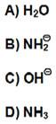

- A

- B

- C

- D

Bloom's Level: 2. Understand

Chapter: 01

Difficulty: Medium

Gradable: automatic

Section: 01.14

Subtopic: Predicting acid/base reaction equilibrium

Topic: Acids and Bases

40. In the equilibrium below, the strongest acid is:
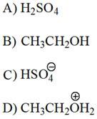

- A

- B

- C

- D

Bloom's Level: 2. Understand

Chapter: 01

Difficulty: Medium

Gradable: automatic

Section: 01.14

Subtopic: Factors affecting acid strength

Subtopic: Predicting acid/base reaction equilibrium

Topic: Acids and Bases

41. Which one of the following is the strongest base?
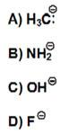

- A

- B

- C

- D

Bloom's Level: 2. Understand

Chapter: 01

Difficulty: Medium

Gradable: automatic

Section: 01.13

Subtopic: Factors affecting acid strength

Topic: Acids and Bases

42. Which one of the following mechanistically depicts the protonation of methanol by hydrogen bromide?
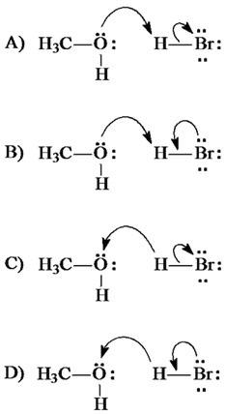

- A

- B

- C

- D

Bloom's Level: 2. Understand

Chapter: 01

Difficulty: Medium

Gradable: automatic

Section: 01.11

Subtopic: Curved arrow notation

Topic: Curved Arrows

43. Which one of the following is the strongest acid?

- FCH₂CO₂H

- ClCH₂CO₂H
- BrCH₂CO₂H
- ICH₂CO₂H

Accessibility: Keyboard Navigation

Bloom's Level: 4. Analyze

Chapter: 01

Difficulty: Hard

Gradable: automatic

Section: 01.13

Subtopic: Factors affecting acid strength

Topic: Acids and Bases

44. Which one of the following has the largest acid equilibrium constant, K_{a?}

- CH₃CO₂H

- CH₂ClCO₂H
- CHCl₂CO₂H
- CCl₃CO₂H

Accessibility: Keyboard Navigation

Bloom's Level: 4. Analyze

Chapter: 01

Difficulty: Hard

Gradable: automatic

Section: 01.13

Subtopic: Factors affecting acid strength
Subtopic: pK_{a}
Topic: Acids and Bases

45. For which of the following does the equilibrium favor reactants?
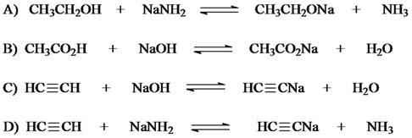

- A

- B

- C

- D

Bloom's Level: 4. Analyze

Chapter: 01

Difficulty: Hard

Gradable: automatic

Section: 01.14

Subtopic: Predicting acid/base reaction equilibrium

Topic: Acids and Bases

46. Identify the resonance structure that results from the following "electron pair movements."
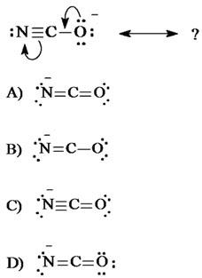

- A

- B

- C

- D

Bloom's Level: 3. Apply

Chapter: 01

Difficulty: Medium

Gradable: automatic

Section: 01.07

Subtopic: Resonance

Topic: Structure and Bonding

47. A Lewis structure of the azide ion, N₃¯, is shown below. The formal charge on the middle nitrogen atom is:
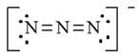

- +2

- +1

- 0

- -1

Bloom's Level: 3. Apply

Chapter: 01

Difficulty: Medium

Gradable: automatic

Section: 01.05

Subtopic: Formal charges

Topic: Structure and Bonding

48. Identify the species that results from the following movement of electron pairs.

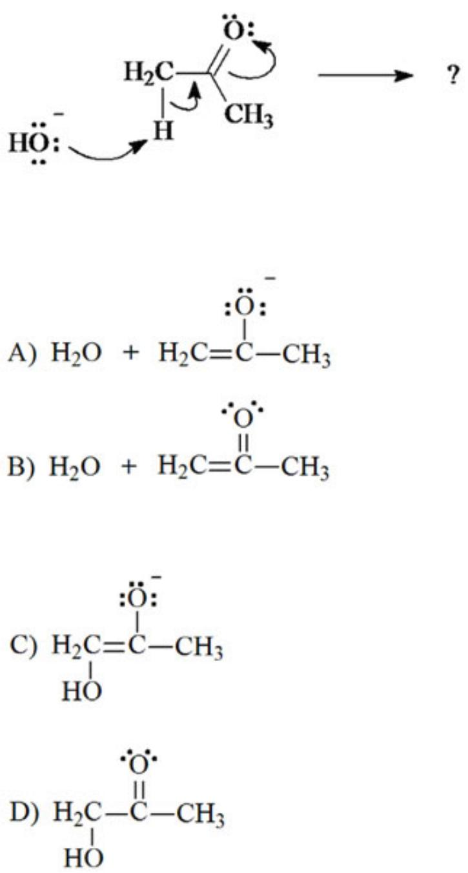

- A

- B

- C

- D

Bloom's Level: 3. Apply

Chapter: 01

Difficulty: Hard

Gradable: automatic

Section: 01.11
Subtopic: Bond formation and bond breaking

Subtopic: Curved arrow notation

Subtopic: Drawing and interpretation

Topic: Curved Arrows

49. The most stable resonance contributor of this would be:
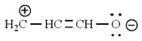
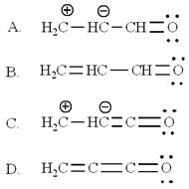

- A

- B

- C

- D

Bloom's Level: 4. Analyze

Chapter: 01

Difficulty: Medium

Gradable: automatic

Section: 01.07

Subtopic: Resonance

Topic: Structure and Bonding

50. What is the molecular formula of aspirin?
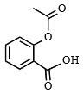

- C₆H₄O₄

- C₈H₈O₄
- C₉H₈O₄
- C₉H₁₀O₄

Bloom's Level: 2. Understand

Chapter: 01

Difficulty: Medium

Gradable: automatic

Section: 01.06

Subtopic: Skeletal/bond-line structures

Topic: Drawing Organic Molecules

51. Which of the following is not identical to the others?
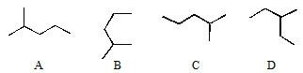

- A

- B

- C

- D

Bloom's Level: 2. Understand

Chapter: 01

Difficulty: Easy

Gradable: automatic

Section: 01.06

Subtopic: Skeletal/bond-line structures

Topic: Drawing Organic Molecules

52. Which of the line-bond structures below cannot represent a stable molecule?
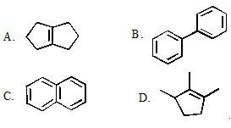

- A

- B

- C

- D

Bloom's Level: 2. Understand

Chapter: 01

Difficulty: Medium

Gradable: automatic

Section: 01.06

Subtopic: Skeletal/bond-line structures

Topic: Drawing Organic Molecules

53. Which of the electron-movement arrows below are NOT valid?
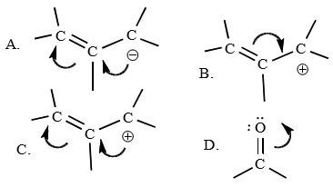

- A

- B

- C

- D

Bloom's Level: 2. Understand

Chapter: 01

Difficulty: Medium

Gradable: automatic

Section: 01.07

Subtopic: Resonance

Topic: Structure and Bonding

54. What atom would have a formal charge in this structure?
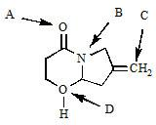

- A

- B

- C

- D

Bloom's Level: 2. Understand

Chapter: 01

Difficulty: Medium

Gradable: automatic

Section: 01.05

Subtopic: Formal charges

Topic: Structure and Bonding

55. Rank the following in order of decreasing acidity. (more acidic > less acidic)
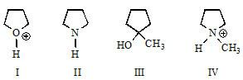

- I > IV > III > II

- IV > I > II > III

- III > II > I > IV

- I > III > IV > II

Bloom's Level: 4. Analyze

Chapter: 01

Difficulty: Hard

Gradable: automatic

Section: 01.13

Subtopic: Acid/Base definitions

Subtopic: Factors affecting acid strength

Topic: Acids and Bases

56. Using resonance principles, what atom is acid first protonated in the molecule shown?
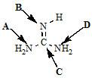

- A

- B

- C

- D

Bloom's Level: 4. Analyze

Chapter: 01

Difficulty: Hard

Gradable: automatic

Section: 01.13

Subtopic: Acid/Base definitions

Subtopic: Factors affecting acid strength

Subtopic: Resonance

Topic: Acids and Bases

Topic: Structure and Bonding

57. What structure would result from these electron movement arrows?
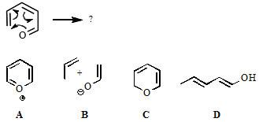

- A

- B

- C

- D

Bloom's Level: 3. Apply

Chapter: 01

Difficulty: Medium

Gradable: automatic

Section: 01.07

Subtopic: Bond formation and bond breaking

Subtopic: Curved arrow notation

Subtopic: Drawing and interpretation

Topic: Curved Arrows

58. What would be the line-bond structure for (CH₃)₃CCH₂CH(CH₃)₂?
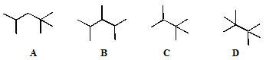

- A

- B

- C

- D

Bloom's Level: 2. Understand

Chapter: 01

Difficulty: Medium

Gradable: automatic

Section: 01.06

Subtopic: Condensed formula

Subtopic: Skeletal/bond-line structures

Topic: Drawing Organic Molecules

Category | # of Questions
Accessibility: Keyboard Navigation | 23
Bloom's Level: 1. Remember | 1
Bloom's Level: 2. Understand | 23
Bloom's Level: 3. Apply | 23
Bloom's Level: 4. Analyze | 11
Chapter: 01 | 58
Difficulty: Easy | 5
Difficulty: Hard | 16
Difficulty: Medium | 37
Gradable: automatic | 58
Section: 01.01 | 2
Section: 01.02 | 1
Section: 01.04 | 4
Section: 01.05 | 8
Section: 01.06 | 13
Section: 01.07 | 6
Section: 01.08 | 1
Section: 01.09 | 6
Section: 01.10 | 3
Section: 01.11 | 4
Section: 01.12 | 2
Section: 01.13 | 5
Section: 01.14 | 3
Subtopic: Acid/Base definitions | 4
Subtopic: Atomic orbitals | 1
Subtopic: Bond formation and bond breaking | 5
Subtopic: Bond properties | 4
Subtopic: Condensed formula | 2
Subtopic: Constitutional isomers | 3
Subtopic: Curved arrow notation | 3
Subtopic: Dipole moments | 3
Subtopic: Drawing and interpretation | 5
Subtopic: Factors affecting acid strength | 6
Subtopic: Formal charges | 9
Subtopic: Hybridization | 2
Subtopic: Octet rule exceptions | 1

Subtopic: Periodic table trends | 2
Subtopic: pK_{a} | 1
Subtopic: Polarity of molecules | 3
Subtopic: Predicting acid/base reaction equilibrium | 3
Subtopic: Resonance | 6
Subtopic: Skeletal/bond-line structures | 10
Subtopic: Types of bonds | 4
Subtopic: VSEPR theory | 5
Topic: Acids and Bases | 10
Topic: Curved Arrows | 6
Topic: Drawing Organic Molecules | 13
Topic: Molecular Shape | 10
Topic: Structure and Bonding | 21

