Chapter 1
Fundamental Concepts in Economics
Experiment: Description
Handout: Student Instructions
Experiment: Administrator’s Guide
Chapter 1 and Chapter 1 Appendix End-of-Chapter Solutions
Experiment:
The Ultimatum Game: Are You Generous or Greedy?
Description: Students are given a sum of money, and asked to offer some of it to an anonymous classmate. If the anonymous classmate accepts the offer, the classmate receives the offer and the first student keeps the remainder. If the anonymous classmate rejects the offer, each receives nothing.
Learning Objective and section the activity most strongly supports:
Learning Objective 1.3 Describe how incentives can affect behavior.
Section 1.3 Key Principle of Economics: People Respond to Incentives
Learning goal: Students explore how individual incentives can be shaped by the alternatives available to others and learn that people define “fairness” in different ways.

HANDOUT
Student Instructions:
The Ultimatum Game
In this game, your instructor will randomly pair you with a classmate. The pairings will be anonymous—no player will know who his or her partner is.
One of the pair will be designated as the “allocator.” The other will be designated as the “receiver.” You will get the chance to play both roles during today’s game.
At the beginning of the game, the allocator will receive $1,000. However, there is a condition: The allocator must offer some portion of those dollars to the receiver. The allocator may offer as few as zero dollars; he may offer as many as $1,000.
The receiver then has a chance to either accept or reject the allocator’s offer. If the offer is accepted, the receiver will receive the amount offered; the allocator will earn whatever is left over ($1,000 minus the amount offered). If the receiver rejects the allocator’s offer, neither player will receive anything.
Your instructor will outline the procedures for submitting offers.

Discussion Points
The Ultimatum Game highlights two important concepts from this chapter:
- First, the Ultimatum Game illustrates the concept of trade-offs. Consider the decisions an allocator makes: if the offer is too generous, the allocator was giving away money that he didn’t have to. If the allocator offered too little, he ran the risk of having his offer rejected. So the allocator faced the question, “What is the minimum amount I must give away to convince the receiver to accept my offer?”
- Second, the Ultimatum Game illustrates just how difficult it is to pinpoint “fairness.” In a student’s role as receiver, she received an offer from an anonymous allocator. Chances are that the offer was greater than zero. Did each student accept what she was offered? An economist would suggest accepting any offer that makes you better off: If your allocator offers you $1, you should take it. But in the real world, someone who is randomly given $1,000 and told to offer some of it to neighbors might be expected to offer a significant share of the money or face social consequences. It can be very difficult to separate what economists consider sensible behavior from what non-economists might consider reasonable.
- People have different notions of fair. Allocaters’ offers and receivers’ decisions may lend insight into what they consider fair. Many students may consider $500 was a fair offer; others may others might think $200 or $300 perfectly reasonable.
- However, it can be hard to discern from students’ actions exactly what they believe constitutes “fair.” Some of the receivers might have thought that $400 constituted a fair offer but indicated that they were willing to accept less simply because, fair or unfair, something is better than nothing. On the other side of the transaction, some of the allocators might have made offers of $500 or $600—not because they thought it was a fair amount but because they were worried that the receiver might reject a smaller offer. In other words, when economists observe the Ultimatum Game, sometimes the generous offers are motivated by “fear” and not by “fair.”
Administrator’s Guide
This chapter’s experiment is designed to show students one of the big reasons why this text downplays discussions of fairness in its treatment of various topics. It does this by shedding some light on exactly how amorphous conceptions of fair are—that different people have different notions of fairness and that figuring out what everyone considers to be fair by observing their behavior can be quite difficult.
This experiment also serves as a precursor to two other experiments that you may wish your students to play. One, the Dictator Game, is presented in the next chapter. The other experiment is a variant on the Dictator Game that is designed to shed light on exactly how altruistic humans really are. That experiment is presented in the instructor’s manual for Chapter 12, which discusses a phenomenon known as the Volunteer’s Dilemma.
Administering the Game: There are many ways to administer the Ultimatum Game. You might want to coordinate offers and acceptances after hours by email. You might want to have allocators write down offers that you can then anonymously communicate to randomly chosen receivers.
But methods such as these require you to be in the middle, which is both labor intensive and slow. An easier way to administer this experiment yields results similar to those obtained in controlled experimental settings.
First, ask each student to play the role of allocator. On a 3×5 index card that you provide, ask each student to write the following, filling in the blanks where appropriate:
“My name is_________, and I offer the receiver _______.”
Collect the cards, shuffle them, and place them in a stack.
Next, ask each student to play the role of receiver. On a second 3×5 index card, ask them to write the following and fill in the blanks where appropriate:
“My name is _______, and the minimum offer I am willing to accept is _______.”
Collect these cards, shuffle them, and place them in a stack.
In the first stack, you have offers. In the second, you have acceptances/rejections. Draw pairs of cards, one from each stack. Read the name of the allocator and her offer, and then read the name of the receiver and her minimum willingness to accept. If the offer is greater than the receiver’s minimum, announce that the offer has been accepted. If the offer is less than the receiver’s minimum, announce that both parties will receive nothing. Staple the cards together, set them aside, and repeat the process with the next cards in each stack.
If you are teaching a large section, skip the in-class announcement of results. Instead, simply write down on the allocators’ cards whether a particular offer was accepted or rejected and to write down on the receivers’ cards whether the offer was above their minimum. The cards can then be returned to the students in a subsequent class period.
When all the pairings have been completed, you may find it useful to calculate the average offer and the most frequently appearing offer. These can be communicated to students or held back until the Dictator Game has been completed.

Based on W. Guth, R. Schmittberger, and B. Schwarze, “An Experimental Analysis of Ultimatum Bargaining,” Journal of Economic Behavior and Organization, 3, 367–388, 1982.
End-of-Chapter Solutions
1.1 economics
1.2 market
1.3 d
1.4 b
1.5 c
1.6 Pros: Markets encourage innovation by promising profits to firms that come up with better treatments; strong competition helps ensure low prices and good service. Cons: Health care is left only to those who can afford it, which is not equitable. Also, the government can, if it chooses, command the huge resources necessary to solve big health problems.
1.7 The draft represents the command system of marshaling resources. That may be necessary because many people—perhaps too many people—would like to avoid high-risk activities like combat at a time when combat is very likely. That, in turn, may make it harder to win wars.

2.1 Scarcity
2.2 opportunity cost (implicit cost acceptable)
2.3 explicit
2.4 a
2.5 b
2.6 c
2.7 d
2.8 a
2.9 List some explicit costs: tuition, books, lab fees. Don’t include housing/food if you would be purchasing housing/food anyway. Then, list implicit costs: For many of you, the opportunity cost of attending college might be working at a good full-time job; you can calculate the value of that opportunity loss by adding up your salary over the four years you will be in college.
2.10 Society is probably worse off because its resources—namely, the talents of Superman, are being underutilized. Application 1.1 suggests that Superman’s abilities could produce more value for society if applied elsewhere; as a result society is poorer than it could otherwise be.
2.11Those economies were command economies. They were able to centrally select and conscript the most promising athletes, who had little choice but to comply. Further, at a national level, they could sacrifice other things (like consumer goods production, for example) and pump resources into their Olympic programs. The cost: the resources (including the athlete’s labor talents) necessary to create such outsized Olympic success could have been used to produce other things that might have been more valued by society.
2.12 The big trade-off is between right to privacy (which is a benefit we all enjoy) with greater security—particularly from terrorist threats (which we also benefit from).
2.13 As of this writing, “Gangnam Style” has been viewed 2,039,916,167 times. The video is 4:12 long. That means that viewers have spent about 8,567,647,901 minutes watching this video. That’s equivalent to about 142,794,132 hours. If the Empire State building took about 7,000,000 hours to complete, then the opportunity cost of “Gangnam Style” is 142, 794,132 ÷ 7,000,000 = 20.4 Empire State Buildings.

3.1 d
3.2 c
3.3 b
3.4 It makes larger homes (with correspondingly bigger mortgages) look more affordable, and provides an incentive to buy/build a bigger home than you otherwise would.
3.5 Artificially cheap food means that consumers can (and will) buy more than they would have if food were not subsidized. Thus, waistlines expand.
3.6 The government can either increase the cost of driving, or increase the benefits of driving less. To raise the cost of driving, government might tax gasoline. Or, it could punish people who drive more than a set amount with a fine (perhaps requiring a regular odometer check.) To increase the benefits of driving less, it could pay people who reduce their driving—perhaps again requiring an annual odometer check. Of these solutions, the gas tax is probably the easiest to implement.
3.7 People would, in the future, be reluctant to accumulate wealth for fear of losing it again. They would spend down their wealth instead. This would likely harm saving, making less money available to borrow for houses or businesses.

4.1 collective action
4.2 b
4.3 Everybody wants the elevator fixed, but nobody wants to pay for it themselves. People on the first few floors can get by without an elevator, but people on Floor 40 must have one. The real-world solution is to create a condominium association that charges a regular maintenance fee, and pay for the elevator repair out of those fees. An alternative solution can be found in the former Soviet republic of Georgia: There, buildings have pay elevators that charge residents a particular amount per floor; the fees collected are used to pay for repairs.
4.4 Students will likely fill out their papers, regardless. That’s because each may fear a hyper-competitive student who answers his exam in hopes of getting an A while screwing his classmates. Or it may happen because your fellow students fear that not everybody understands the plan or that not everyone may have been paying attention. If you think even one student will fill something out, you have to fill something out, too, or risk getting a zero. In the end, students all fill out exams (soaking up resources) to get the same grade (or worse) they would have gotten if they had all left their papers blank.

5.1 normative
5.2 benevolent social planner
5.3 d
5.4 c
5.5 a
5.6 That decision was based on normative economics. Unemployment means idle resources and reduced wealth. Government made an explicit choice to make society poorer overall because it believed that people who are working should make a livable wage.
5.7 The BSP would probably not support this scheme. Lots of people would spend time waiting in line, which is wasteful. Perhaps more important, the hams would go to the first 100 people, not necessarily the 100 people that like ham the most.

Chapter 1 Appendix End-of-Chapter Solutions
1.1 demand curve
1.2 b
1.3 By cutting prices, the stores can induce consumers to buy more (as the law of demand predicts). That helps stores clear shelves so they can begin stocking spring merchandise.
1.4 Taxing cigarettes increases their price, which (as the law of demand predicts) causes smokers to smoke less.

2.1 b
2.2 d
2.3 Increases in the price of oil encourage oil producers to bring more oil to market. They will increase pumping, drilling, and exploration in order to ramp up production.

3.1 shortage
3.2 b
3.3 Equilibrium price = $30,000; equilibrium quantity = 40,000 units.
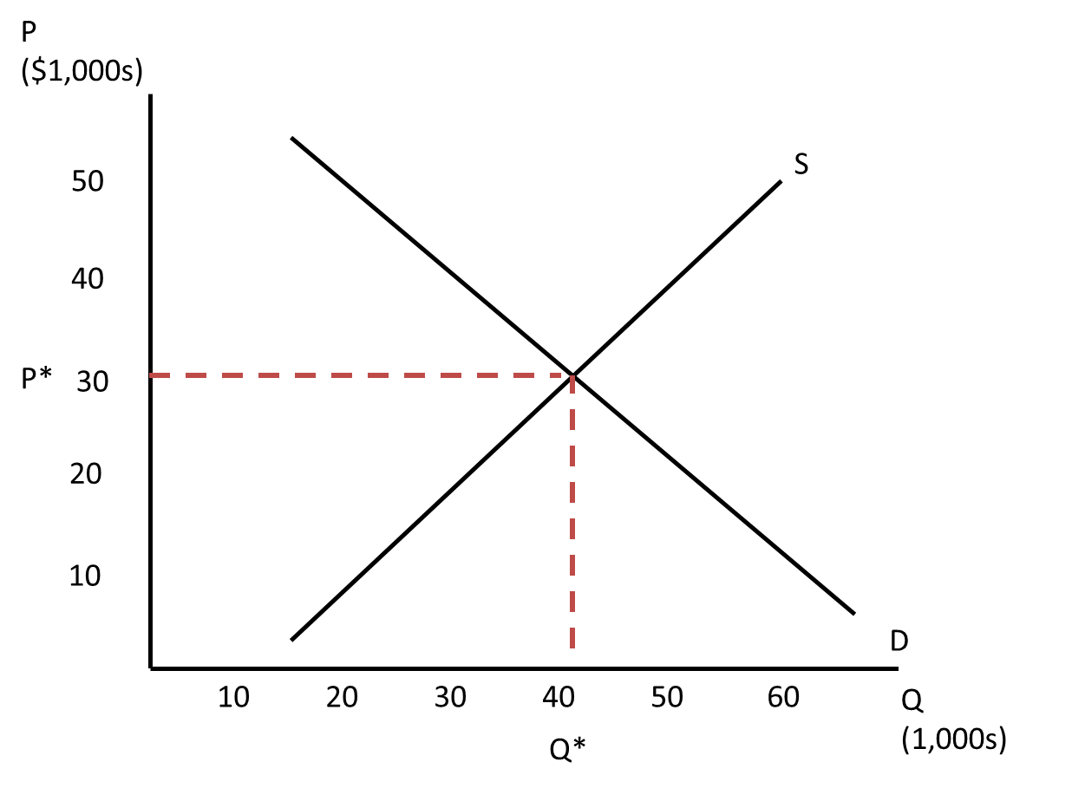

4.1 b
4.2 b
4.3 Original table:
Price | $10,000 | $15,000 | $20,000 | $25,000 | $30,000 | $35,000 | $40,000 | $45,000
Quantity demanded per month | 60,000 | 55,000 | 50,000 | 45,000 | 40,000 | 35,000 | 30,000 | 25,000
Quantity supplied per month | 20,000 | 25,000 | 30,000 | 35,000 | 40,000 | 45,000 | 50,000 | 55,000
New table:
Price | $10,000 | $15,000 | $20,000 | $25,000 | $30,000 | $35,000 | $40,000 | $45,000
Quantity demanded per month | 50,000 | 45,000 | 40,000 | 35,000 | 30,000 | 25,000 | 20,000 | 15,000
Quantity supplied per month | 20,000 | 25,000 | 30,000 | 35,000 | 40,000 | 45,000 | 50,000 | 55,000
The new demand curve is to the left of the original one by 10,000 units.
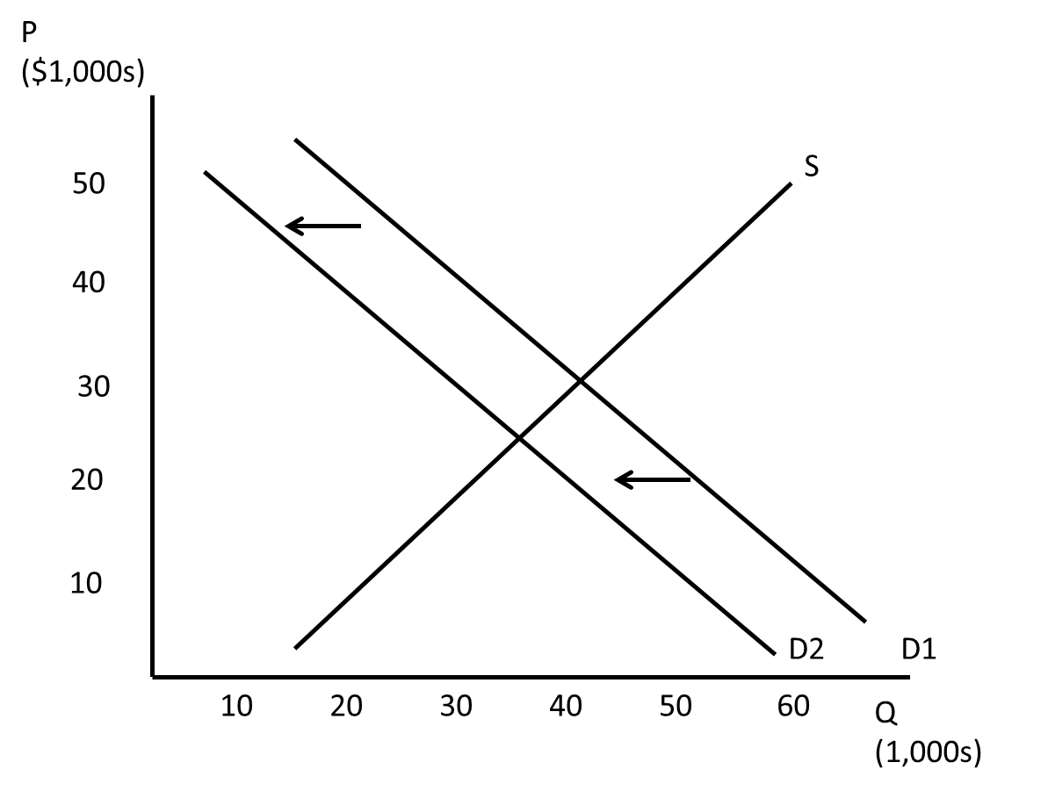
4.4 The new equilibrium price is $25,000; the new equilibrium quantity is 35,000 cars.
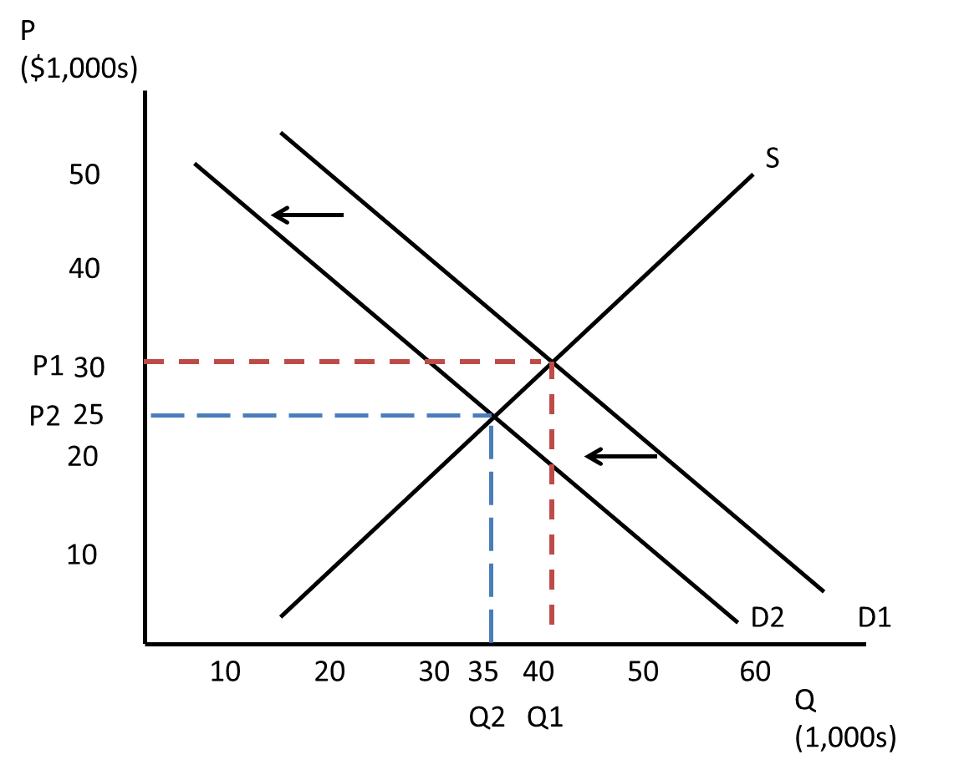
4.5 Original table:
Price | $10,000 | $15,000 | $20,000 | $25,000 | $30,000 | $35,000 | $40,000 | $45,000
Quantity demanded per month | 60,000 | 55,000 | 50,000 | 45,000 | 40,000 | 35,000 | 30,000 | 25,000
Quantity supplied per month | 20,000 | 25,000 | 30,000 | 35,000 | 40,000 | 45,000 | 50,000 | 55,000
New table:
Price | $10,000 | $15,000 | $20,000 | $25,000 | $30,000 | $35,000 | $40,000 | $45,000
Quantity demanded per month | 60,000 | 55,000 | 50,000 | 45,000 | 40,000 | 35,000 | 30,000 | 25,000
Quantity supplied per month | 10,000 | 15,000 | 20,000 | 25,000 | 30,000 | 35,000 | 40,000 | 45,000
The new equilibrium price is $35,000; the new equilibrium quantity is 35,000 cars.
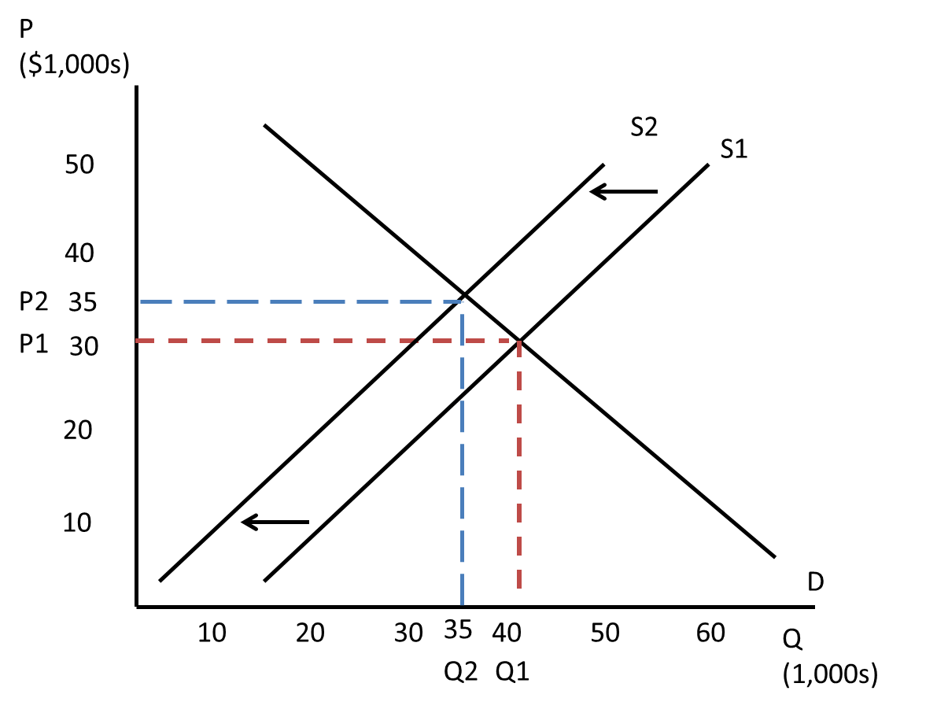
5.1 complements
5.2 input
5.3 b
5.4 a. The demand for coffee increases: P increases; Q increases
b. The demand for coffee decreases: P decreases; Q decreases
c. The supply of coffee decreases: P increases; Q decreases
d. The demand for coffee decreases: P decreases; Q decreases
e. The supply of coffee decreases: P increases; Q decreases
5.5 Event 1: d
Event 2: a
Event 3: b
Event 4: c

6.1 price elasticity of demand (elasticity acceptable)
6.2 inelastic
6.3 b
6.4 Create graph to illustrate. Let supply be nearly horizontal, and demand shift a lot. Still, price won’t increase by much.
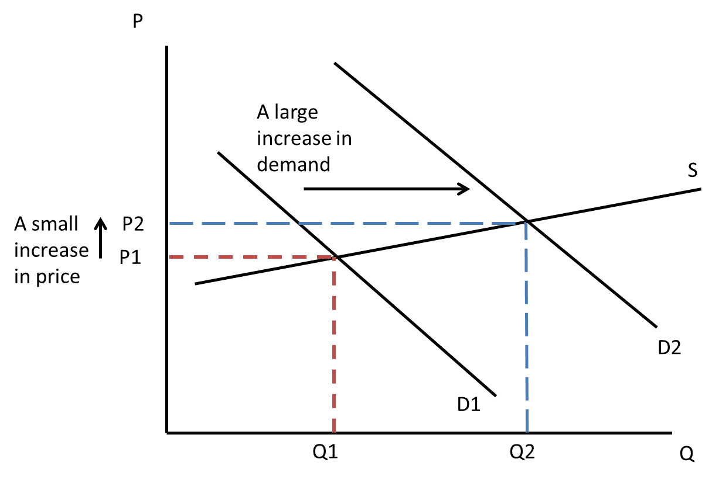
6.5 a.
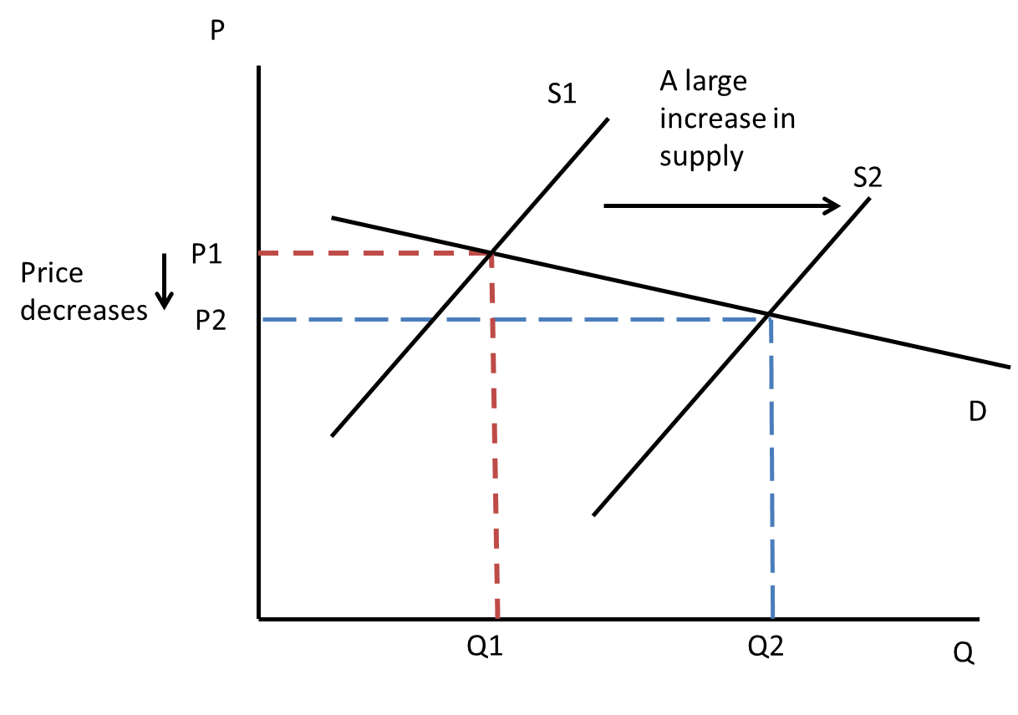

b.
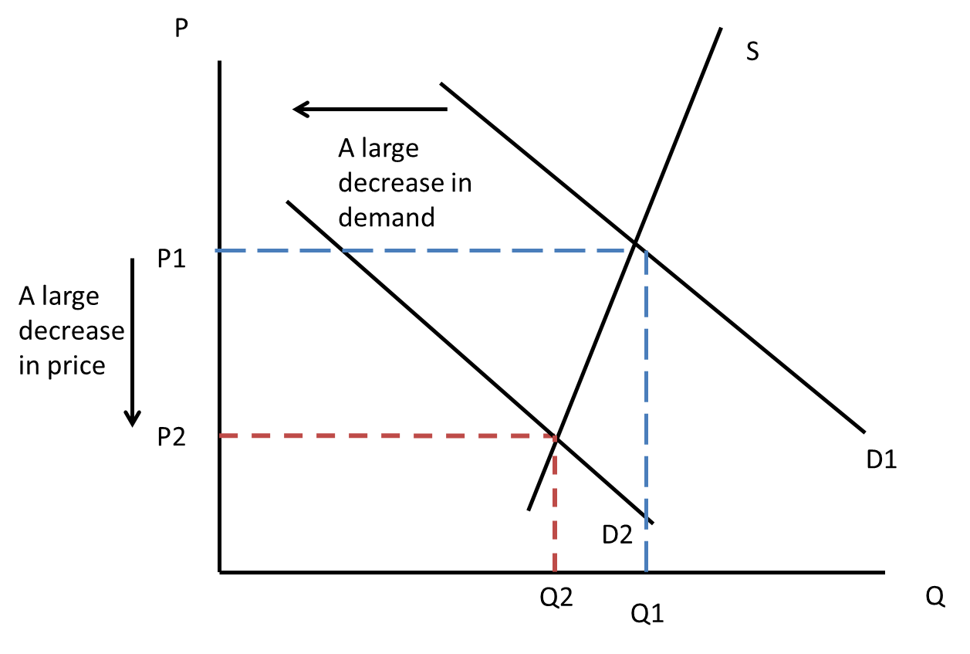
c.
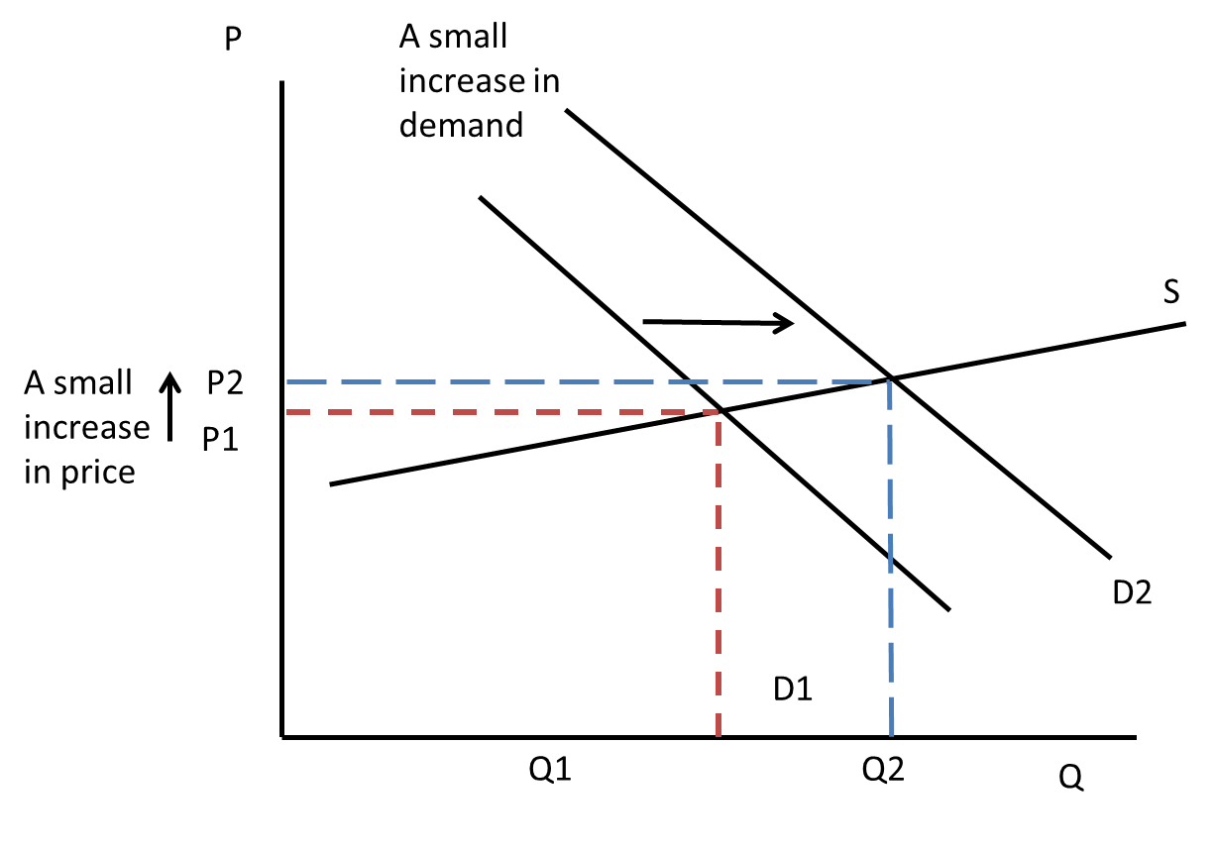
d.
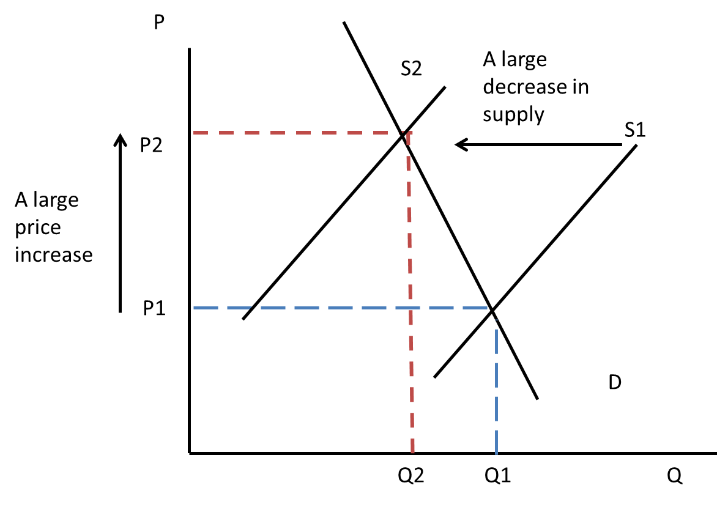
Case d will result in the largest price increase.

