1. Decide whether the following problem can be solved using precalculus, or whether calculus is required. If the problem can be solved using precalculus, solve it. If the problem seems to require calculus, use a graphical or numerical approach to estimate the solution.
​
Find the distance traveled in 13 seconds by an object traveling at a constant velocity of 15 feet per second.
​
 | a. | calculus, 195 ft
 | b. | calculus, 215 ft
 | c. | precalculus, 195 ft
 | d. | calculus, 390 ft
 | e. | precalculus, 390 ft

ANSWER: | c
POINTS: | 1
DIFFICULTY: | Easy
REFERENCES: | Section 1.1
QUESTION TYPE: | Multi-Mode (Multiple choice)
HAS VARIABLES: | True
LEARNING OBJECTIVES: | LCalc11.1.1.2 - Understand that the tangent line problem is basic to calculus.
OTHER: | Skill
DATE CREATED: | 1/11/2017 9:56 AM
DATE MODIFIED: | 1/11/2017 9:56 AM

2. Decide whether the following problem can be solved using precalculus, or whether calculus is required. If the problem can be solved using precalculus, solve it. If the problem seems to require calculus, use a graphical or numerical approach to estimate the solution.
​
Find the distance traveled in 19 seconds by an object moving with a velocity of feet per second. Round your answer to four decimal places.
​
 | a. | calculus, 215.9209 ft
 | b. | precalculus, 217.2709 ft
 | c. | calculus, 210.0491 ft
 | d. | precalculus, 210.0491 ft
 | e. | precalculus, 215.9209 ft

ANSWER: | c
POINTS: | 1
DIFFICULTY: | Medium
REFERENCES: | Section 1.1
QUESTION TYPE: | Multi-Mode (Multiple choice)
HAS VARIABLES: | True
LEARNING OBJECTIVES: | CALC052 - Recognize problems requiring calculus and estimate solutions
OTHER: | Skill
DATE CREATED: | 1/11/2017 9:56 AM
DATE MODIFIED: | 1/11/2017 9:56 AM

3. Decide whether the following problem can be solved using precalculus, or whether calculus is required. If the problem can be solved using precalculus, solve it. If the problem seems to require calculus, use a graphical or numerical approach to estimate the solution.
​
A cyclist is riding on a path whose elevation is modeled by the function where x and are measured in miles. Find the rate of change of elevation when .
​
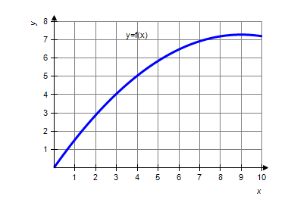
​
 | a. | precalculus, 0.09
 | b. | calculus, 0.21
 | c. | calculus, 0.81
 | d. | calculus, 0.09
 | e. | precalculus, 0.21

ANSWER: | c
POINTS: | 1
DIFFICULTY: | Medium
REFERENCES: | Section 1.1
QUESTION TYPE: | Multi-Mode (Multiple choice)
HAS VARIABLES: | True
LEARNING OBJECTIVES: | CALC052 - Recognize problems requiring calculus and estimate solutions
OTHER: | Skill
DATE CREATED: | 1/11/2017 9:56 AM
DATE MODIFIED: | 1/11/2017 9:56 AM

4. Decide whether the following problem can be solved using precalculus, or whether calculus is required. If the problem can be solved using precalculus, solve it. If the problem seems to require calculus, use a graphical or numerical approach to estimate the solution.
​
A cyclist is riding on a path whose elevation is modeled by the function where x and are measured in miles. Find the rate of change of elevation when . Round your answer to two decimal places, if necessary.
​
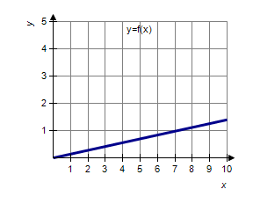
​
 | a. | calculus, 0.98
 | b. | precalculus, 0.14
 | c. | calculus, 0.14
 | d. | precalculus, 0.98
 | e. | precalculus, 0.39

ANSWER: | b
POINTS: | 1
DIFFICULTY: | Easy
REFERENCES: | Section 1.1
QUESTION TYPE: | Multi-Mode (Multiple choice)
HAS VARIABLES: | True
LEARNING OBJECTIVES: | LCalc11.1.1.2 - Understand that the tangent line problem is basic to calculus.
OTHER: | Skill
DATE CREATED: | 1/11/2017 9:56 AM
DATE MODIFIED: | 1/11/2017 9:56 AM

5. Decide whether the following problem can be solved using precalculus, or whether calculus is required. If the problem can be solved using precalculus, solve it. If the problem seems to require calculus, use a graphical or numerical approach to estimate the solution.
​
Find the area of the shaded region bounded by the triangle with vertices , , .
​​
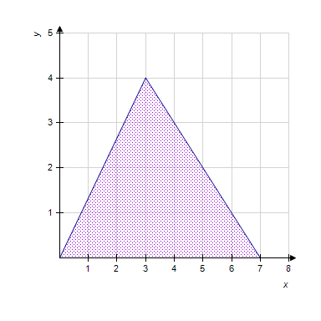
​
 | a. | precalculus, 28
 | b. | calculus, 42
 | c. | precalculus, 14
 | d. | precalculus, 42
 | e. | calculus, 28

ANSWER: | c
POINTS: | 1
DIFFICULTY: | Easy
REFERENCES: | Section 1.1
QUESTION TYPE: | Multi-Mode (Multiple choice)
HAS VARIABLES: | True
LEARNING OBJECTIVES: | LCalc11.1.1.2 - Understand that the tangent line problem is basic to calculus.
OTHER: | Skill
DATE CREATED: | 1/11/2017 9:56 AM
DATE MODIFIED: | 1/11/2017 9:56 AM

6. Decide whether the following problem can be solved using precalculus, or whether calculus is required. If the problem can be solved using precalculus, solve it. If the problem seems to require calculus, use a graphical or numerical approach to estimate the solution.
​
Find the area of the shaded region. Round your answer to the whole number.
​
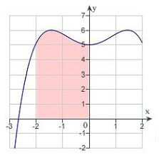
​
 | a. | calculus , 11
 | b. | precalculus , 11
 | c. | precalculus , 13
 | d. | calculus , 16
 | e. | precalculus , 16

ANSWER: | a
POINTS: | 1
DIFFICULTY: | Medium
REFERENCES: | Section 1.1
QUESTION TYPE: | Multi-Mode (Multiple choice)
HAS VARIABLES: | True
LEARNING OBJECTIVES: | CALC053 - Recognize problems requiring calculus and estimate solution
OTHER: | Skill
DATE CREATED: | 1/11/2017 9:56 AM
DATE MODIFIED: | 1/11/2017 9:56 AM

7. Consider the function and the point on the graph of f. Graph f and the secant line passing through and for .
​
 | a. | ​ | b. | ​
 | c. | ​ | d. | ​
 | e. | ​

ANSWER: | d
POINTS: | 1
DIFFICULTY: | Easy
REFERENCES: | Section 1.1
QUESTION TYPE: | Multi-Mode (Multiple choice)
HAS VARIABLES: | True
LEARNING OBJECTIVES: | LCalc11.1.1.0 - A Preview of Calculus
OTHER: | Skill
DATE CREATED: | 1/11/2017 9:56 AM
DATE MODIFIED: | 1/11/2017 9:56 AM

8. Consider the function and the point on the graph of f. Find the slope of the secant line passing through and for . Round your answer to four decimal places.
​
 | a.
 | b. | ​
 | c.
 | d.
 | e.

ANSWER: | a
POINTS: | 1
DIFFICULTY: | Easy
REFERENCES: | Section 1.1
QUESTION TYPE: | Multi-Mode (Multiple choice)
HAS VARIABLES: | True
LEARNING OBJECTIVES: | CALC055 - Calculate the slope of a secant line passing through given points
OTHER: | Skill
DATE CREATED: | 1/11/2017 9:56 AM
DATE MODIFIED: | 1/11/2017 9:56 AM

9. Consider the function and the point on the graph of f.
​
Consider the secant lines passing through and for x values of 97, 99, and 101. Find the slope of each secant line to four decimal places. Round your answers to four decimal places, if necessary.
​
(Think about how you could use your results to estimate the slope of the tangent line of f at , and how to improve your approximation of the slope.)
​
 | a. | 0.0504 , 0.0501 , 0.025
 | b. | 0.0504 , –0.0501 , 0.0499
 | c. | 0.0252 , 0.0251 , 0.025
 | d. | 0.0504 , 0.0501 , 0.0499
 | e. | –0.0252 , –0.0251 , –0.025

ANSWER: | d
POINTS: | 1
DIFFICULTY: | Medium
REFERENCES: | Section 1.1
QUESTION TYPE: | Multi-Mode (Multiple choice)
HAS VARIABLES: | True
LEARNING OBJECTIVES: | CALC056 - Calculate the slopes of secant lines
OTHER: | Skill
DATE CREATED: | 1/11/2017 9:56 AM
DATE MODIFIED: | 1/11/2017 9:56 AM

10. Consider the function and the point on the graph of f. Estimate the slope m of the tangent line of f at . Round your answer to four decimal places.
​
a.
b.
c.
d.
e.

ANSWER: | a
POINTS: | 1
DIFFICULTY: | Medium
REFERENCES: | Section 1.1
QUESTION TYPE: | Multi-Mode (Multiple choice)
HAS VARIABLES: | True
LEARNING OBJECTIVES: | CALC057 - Estimate the slope of a tangent line
OTHER: | Skill
DATE CREATED: | 1/11/2017 9:56 AM
DATE MODIFIED: | 1/11/2017 9:56 AM

11. Consider the function and the point on the graph of f. Graph f and the secant line passing through and for .
​
 | a. | ​ | b. | ​
 | c. | ​ | d. | ​
 | e. | ​

ANSWER: | d
POINTS: | 1
DIFFICULTY: | Easy
REFERENCES: | Section 1.1
QUESTION TYPE: | Multi-Mode (Multiple choice)
HAS VARIABLES: | True
LEARNING OBJECTIVES: | LCalc11.1.1.0 - A Preview of Calculus
OTHER: | Skill
DATE CREATED: | 1/11/2017 9:56 AM
DATE MODIFIED: | 1/11/2017 9:56 AM

12. Consider the function and the point on the graph of f. Find the slope of the secant line passing through and for . Round your answer to one decimal place.
​
 | a. | 7.5
 | b. | 6.0
 | c. | 4.0
 | d. | 5.5
 | e. | 4.0

ANSWER: | b
POINTS: | 1
DIFFICULTY: | Easy
REFERENCES: | Section 1.1
QUESTION TYPE: | Multi-Mode (Multiple choice)
HAS VARIABLES: | True
LEARNING OBJECTIVES: | CALC055 - Calculate the slope of a secant line passing through given points
OTHER: | Skill
DATE CREATED: | 1/11/2017 9:56 AM
DATE MODIFIED: | 1/11/2017 9:56 AM

13. Consider the function and the point on the graph of f. Estimate the slope of the tangent line of f at . Round your answer to the whole number.
​
 | a. | 15
 | b. | 6
 | c. | 13
 | d. | 5
 | e. | 14

ANSWER: | d
POINTS: | 1
DIFFICULTY: | Medium
REFERENCES: | Section 1.1
QUESTION TYPE: | Multi-Mode (Multiple choice)
HAS VARIABLES: | True
LEARNING OBJECTIVES: | CALC058 - Calculate the slope of secant line passing through the given points
OTHER: | Skill
DATE CREATED: | 1/11/2017 9:56 AM
DATE MODIFIED: | 1/11/2017 9:56 AM

14. Use the rectangles in the graph given below to approximate the area of the region bounded by 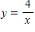, , , and . Round your answer to three decimal places.
​
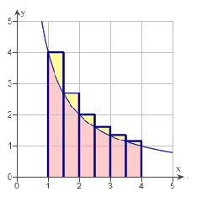
​
 | a. | 2.975 units²
 | b. | 6.871 units²
 | c. | 4.075 units²
 | d. | 6.372 units²
 | e. | 7.397 units²

ANSWER: | b
POINTS: | 1
DIFFICULTY: | Medium
REFERENCES: | Section 1.1
QUESTION TYPE: | Multi-Mode (Multiple choice)
HAS VARIABLES: | True
LEARNING OBJECTIVES: | LCalc11.1.1.3 - Understand that the area problem is also basic to calculus.
OTHER: | Skill
DATE CREATED: | 1/11/2017 9:56 AM
DATE MODIFIED: | 1/11/2017 9:56 AM

15. Consider the length of the graph of 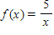 from to . Approximate the length of the curve by finding the sum of the lengths of four line segments, as shown in following figure. Round your answer to two decimal places.
​
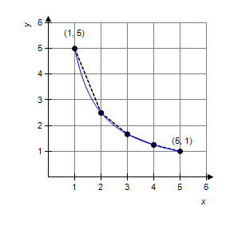
​
 | a. | 6.11
 | b. | 8.12
 | c. | 5.66
 | d. | 8.49
 | e. | 7.11

ANSWER: | a
POINTS: | 1
DIFFICULTY: | Medium
REFERENCES: | Section 1.1
QUESTION TYPE: | Multi-Mode (Multiple choice)
HAS VARIABLES: | True
LEARNING OBJECTIVES: | CALC060 - Estimate the length of the curve using a piecewise linear function
OTHER: | Skill
DATE CREATED: | 1/11/2017 9:56 AM
DATE MODIFIED: | 1/11/2017 9:56 AM

